ICCI Youth Club
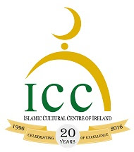
Assalamu-alaikum Wa Rahmatullahi Wa Barakatuhu,

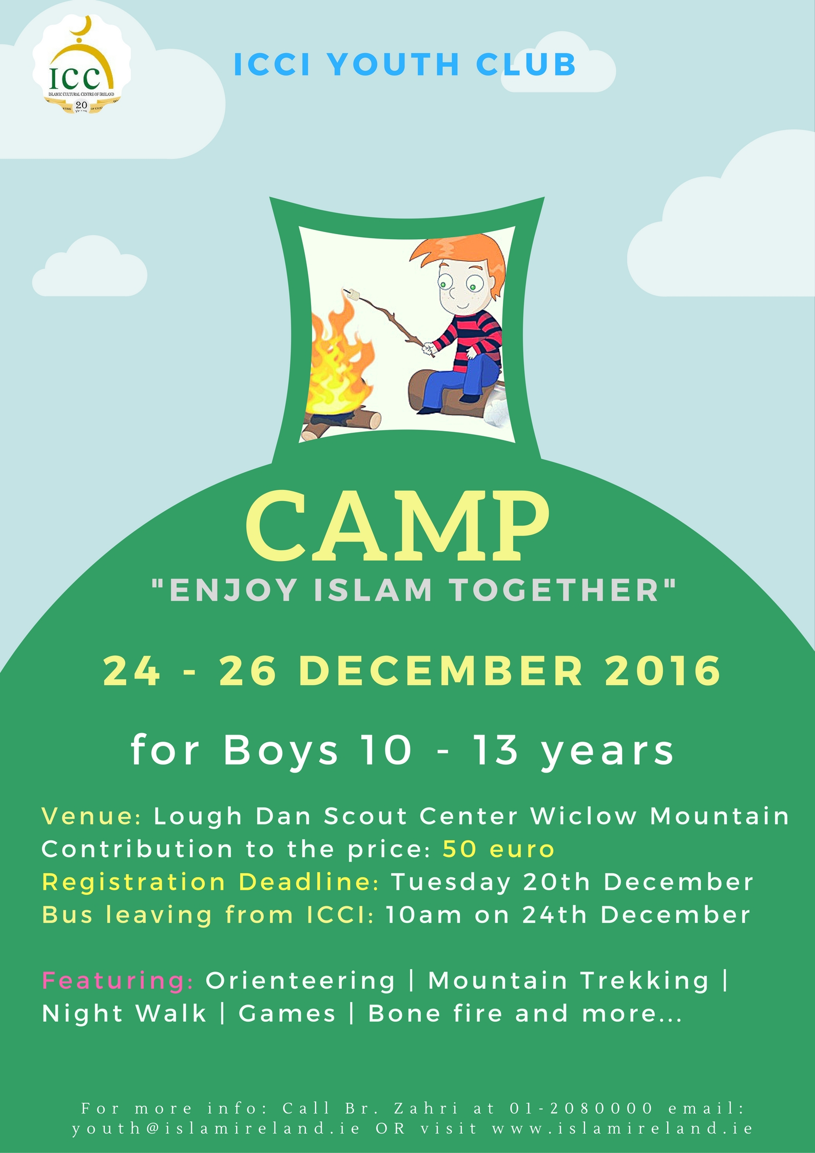

Dear Parents / Brothers and sisters / Dear participants

I would like to inform you that the Youth Club of ICCI is organising an Outdoor Adventure boys camp titled:

“Enjoy Islam Together”

When: Saturday 24th December until Monday 26th December 2016 (3 Days).

Who: Age group or the participants: 10 – 13 years

Why and How: Utilizing the Winter School break with structured recreational activities. - The program will consist of Adventure type Team-based competitions, Sports, Mountain trekking, Orienteering, Entertainment and more.

Fees: The contribution of the cost for each participant is €50
Registration: Places based on 'first come first serve basis' - Limited places!
Deadline for registration and payment: Tuesday 20th December 2016.

To register, fill in the form and return it completed together with the fee of €50 to the ICCI Youth Department.

The Bus will leave from the ICCI on Saturday 24th of December at 10am.
Coming Back on Monday Afternoon at around 1pm inshaallah

All the Boys will be registered, put in groups and will be briefed with the program, activities and the rules and regulations of the camp. The boys will be traveling with the minibuses from ICC to Lough Dan Scout Centre in Wicklow Mountain. Supervisors will be helping throughout the program and will not tolerate any bad behaviour. More importantly the boys will have to bring any medicine they may require (inhalers, tablet etc.), and will need to notify their group leader of any illness they may have. Everyone is responsible for their own belongings.

Please note that every participant should bring the following:

- Own Qur’an, pen and notebook
- Torch
- Sleeping bag
- Toiletries
- Clothing (for mountain trekking, extra clothing and shoes, warm jumpers and jackets )
- Medication if any

Consent Return Slip for the Participant
Name of participant_____________________________________________
Date of Birth: ____/______/________/ Years____________
Mobile number: _________________/ email _______________________
Address: _____________________________________________________
Any comments ________________________________________________
____________________________________________________________

I_____________________________ Parent/Guardian of________________________ give consent for my son to participate in the Camp. I have read and agreed with the information and rules and regulations below and overleaf. I also give consent that his age is the correct age as stated above.
In case of an emergency please contact me on tel.___________________________ or __________________________________________ on tel. _____________________
I have enclosed a contribution of €50

Signature of Parent:_________________ Date:_____________
Important: Alhamdulillah, while we would like the youth to enjoy themselves during our camp, trips and outings and other activities, we remind all participants that we are an Islamic Youth Group and thenceforth all our trips have specific Tarbiyah goals. In order for us to meet these goals and ensure the safety of your son during the camp or trip, we ask you to read together with your son and sign on the following terms and conditions.
Supervision and Discipline
- The Youth Club provide an Islamic alternative for the modern times the youth live in. It also provides guidance, Tarbiyah and nurturing of your son on Islamic morals and etiquettes during the camp / trip. There are supervisors in each activity.
- Your son must abide by the Tarbiyah program as set out by the ICCI youth coordinator, such as offering the five daily prayers, reading a portion of the Qur’an on a daily basis, been punctual and attentive during talks and other activities
- Your son must adhere to Islamic morals, practices and norms during the entire camp/trip.
- The ICCI discipline procedure as outlined in the ICCI discipline policy must be agreed upon by the parents and adhered to by the participant. The Discipline policy offences include: 1. Leaving the centre without the permission of camp in charge (br. Zahri). 2. Disrespect of elders and worshipers who come to the Mosque and rudeness to them. 3. Behaviour in Public which is against accepted Islamic norms or tarnishes the image of the ICCI or is against the rules and regulations of a particular place or an event or which breaks the law. 4. Stealing. 5. Vandalism and behaviour that constitutes a danger to ones self or others around him. 6. Fighting. 7. Damage to property/litter and behaviour that constitutes a danger to ones self or others around him out of negligence. 8. Vulgar behaviour, swearing, insulting, bulling and provocation to each other. 9. Continual disobedience/disrespect of the youth supervisors/leader/speakers/security staff of ICCI.
As well as a discipline policy, there will also be a positive appraisal points system. They include: 1. Attendance of the activities and prayers on exact time. 2. Giving Salaam at all the time and showing kindness and generosity to each other. 3. Outstanding help, assistance and sacrifice for Allah. 4. Excellent presentation, speech, talk or Performance. 5. Thorough execution of tasks as per leader, such as cleaning, serving… 6. No breaking of the camp’s rules.
- The application form should be signed by the parent/guardian and the participant.
- Parents will bear the full responsibility including any financial costs for participant who does not listen to supervisors and subsequently hurts himself or causes any damage, also in a cases where the participant have had to be sent home as a result of continuous misbehavior that is detrimental to the group as a whole. In all these cases the Youth Club of ICCI does not accept any responsibility.
For more information call br. Zahri at 01-208 0000 email: youth@islamireland.ie or www.islamireland.ie

