ICCI Youth Club
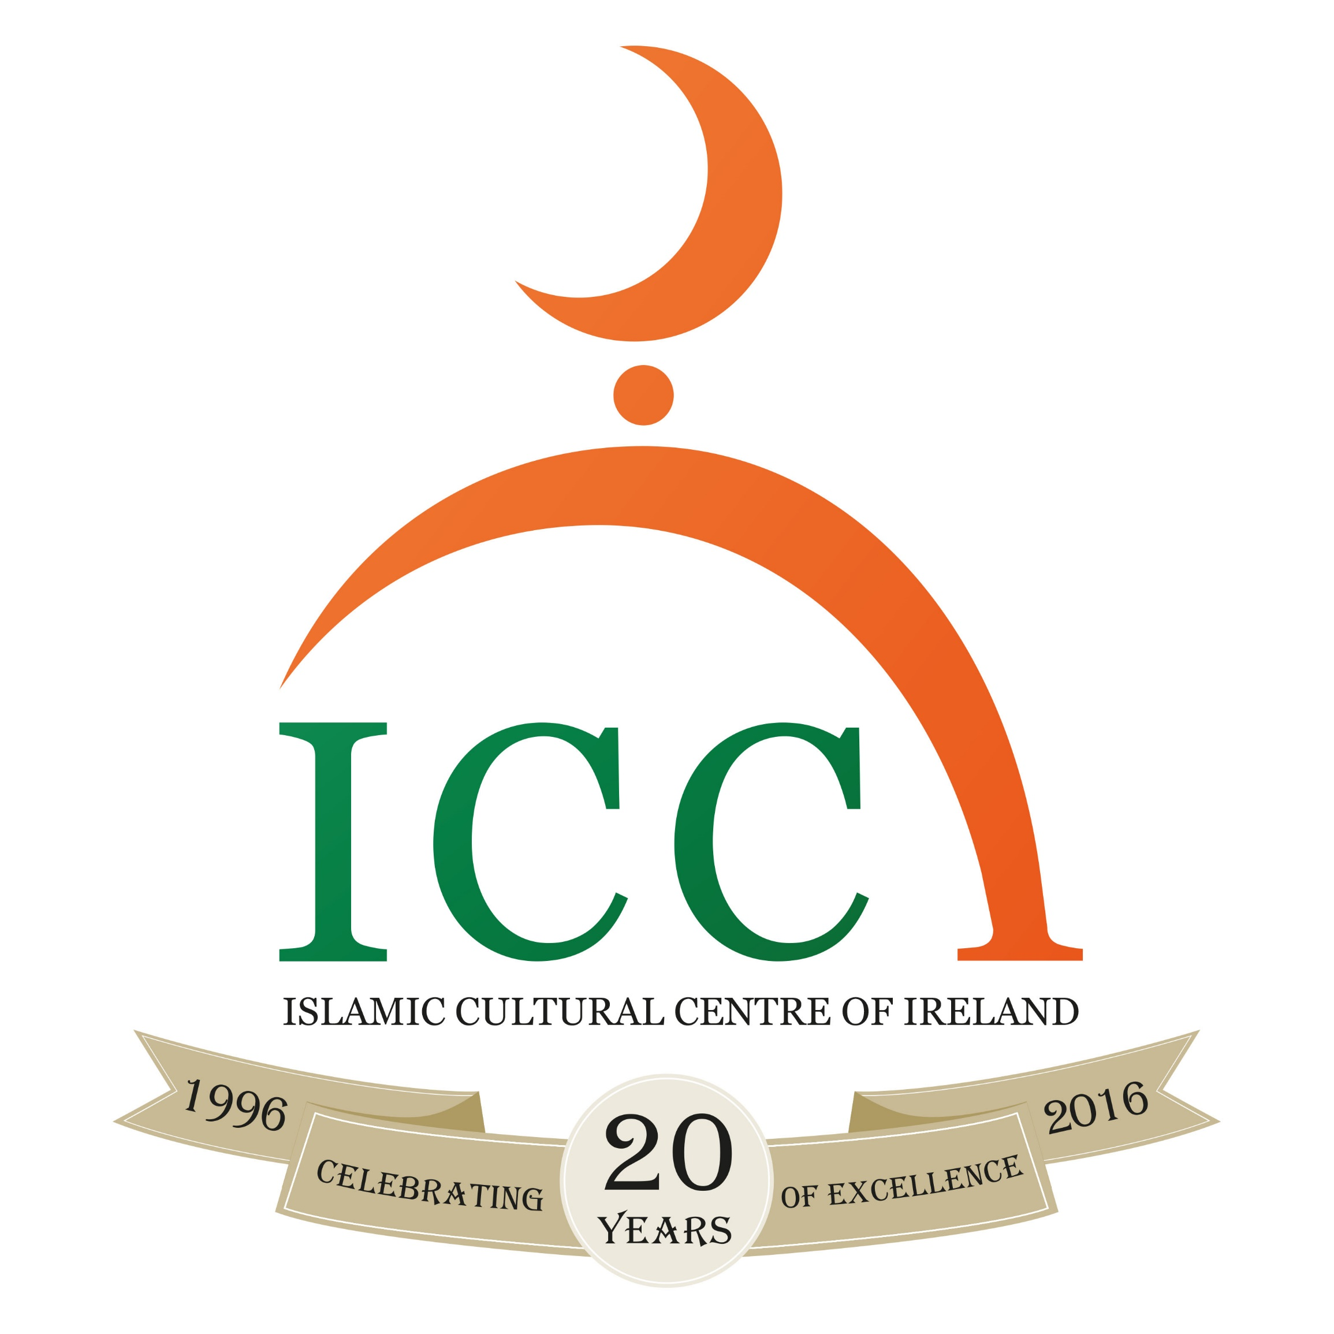

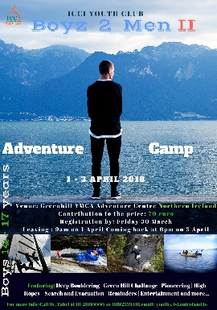
Registration form

Dear Parents / Brothers and sisters / Dear participants, Assalamu alaikum

The Youth Club of ICCI is organising Adventure camp for boys titled:

“Boys to Men ||”

When: Sunday 1th April until Tuesday 3th April 2018 (3 Days);

Where: Green Hill YMCA Adventure Centre Newcastle Co. Down Northern Ireland

Who: Boys: 14 – 17 years

Why and How: Utilizing the Spring Easter School Holiday with structured recreational activities. - The program will consist of Adventure type Team-based competitions, Kayaking, Orienteering, High Ropes Course, Night Walk, Islamic Reminders, Workshop, Entertainment and more.

Fees: The contribution of the cost for each participant is €70
Registration: Places based on 'first come first serve basis' - Limited places!
Deadline for registration and payment: Friday 30th March 2018.

- To register, fill in the form and return it completed together with the fee of €70 to the ICCI Youth Department or the Reception of ICCI.

- The Bus will leave from the ICCI on Sunday 1th April 2018 at 9am.
- Coming Back on Tuesday afternoon at around 6:00pm inshaallah

All the Boys will be registered, put in groups and will be briefed with the program, activities and the rules and regulations of the camp. The boys will be traveling with a Bus from ICCI to Green Hill YMCA Adventure Centre Newcastle Co. Down Northern Ireland. Supervisors will be helping throughout the program and will not tolerate any bad behaviour. More importantly the boys will have to bring any medicine they may require (inhalers, tablet etc.), and will need to notify their group leader of any illness they may have. Everyone is responsible for their own belongings.

Please note that every participant should bring the following:

- Own Qur’an, pen and notebook
- Torch
- Toiletries
- Clothing(4 sets of Old clothing, rain jacket & trousers, 2 Old pair of runners, Warm clothes, Swimsuit, Towels, Plastic bags)
- Medication if any

More info: br. Zahri at 01-208 0000 or 0892559416 email: youth@islamireland.ie or www.islamireland.ie
Consent Return Slip for the Participant
Name of Participant__________________________________________________________________/

Date of Birth: ________/ _________/ _________/ Years: ________________________________/

Mobile number: ___________________________/ email: ________________________________/

Address: __________________________________________________________________________/

Any comments: ____________________________________________________________________/

Return Slip for the Parent

I_____________________________ Parent/Guardian of________________________ give consent for my son to participate in the Camp. I have read and agreed with the information and rules and regulations below and overleaf. I also give consent that his age is the correct age as stated above.
In case of an emergency please contact me on tel.___________________________ or __________________________________________ on tel. _____________________
I have enclosed a contribution of €70

Signature of Parent:_____________ Date:______________ Signature of Participant _____________

Receipt: The ICCI Youth Department Received ___________ euro fee for the “Boys to man ||” camp from _____________________________________________Signature_________________________

Importan: Supervision and Discipline
- The Youth Club provide an Islamic alternative for the modern times the youth live in. It also provides guidance, Tarbiyah and nurturing of your son on Islamic morals and etiquettes during the camp / trip. There are supervisors in each activity.
- Your son must abide by the Tarbiyah program as set out by the ICCI youth coordinator, such as offering the five daily prayers, reading a portion of the Qur’an on a daily basis, been punctual and attentive during talks and other activities
- Your son must adhere to Islamic morals, practices and norms during the entire camp/trip.
- The ICCI discipline procedure as outlined in the ICCI discipline policy must be agreed upon by the parents and adhered to by the participant. The Discipline policy offences include: 1. Leaving the Camp site without the permission of camp in charge ( Zahri). 2. Disrespect of elders and rudeness to them. 3. Behaviour in Public which is against accepted Islamic norms or tarnishes the image of the ICCI or is against the rules and regulations of a particular place or an event or which breaks the law. 4. Stealing. 5. Vandalism and behaviour that constitutes a danger to ones self or others around him. 6. Fighting. 7. Damage to property/litter and behaviour that constitutes a danger to ones self or others around him out of negligence. 8. Vulgar behaviour, swearing, insulting, bulling and provocation to each other. 9. Continual disobedience/disrespect of the youth supervisors/leader/speakers. As well as a discipline policy, there will also be a positive appraisal points system. They include: 1. Attendance of the activities and prayers on exact time. 2. Giving Salaam at all the time and showing kindness and generosity to each other. 3. Outstanding help, assistance and sacrifice for Allah. 4. Excellent presentation, speech, talk or Performance. 5. Thorough execution of tasks as per leader, such as cleaning, serving… 6. No breaking of the camp’s rules.
- The application form should be signed by the parent/guardian and the participant.
- Parents will bear the full responsibility including any financial costs for participant who does not listen to supervisors and subsequently hurts himself or causes any damage, also in a cases where the participant have had to be sent home as a result of continuous misbehavior that is detrimental to the group as a whole. In all these cases the Youth Club of ICCI does not accept any responsibility.

