ICCI Youth Club

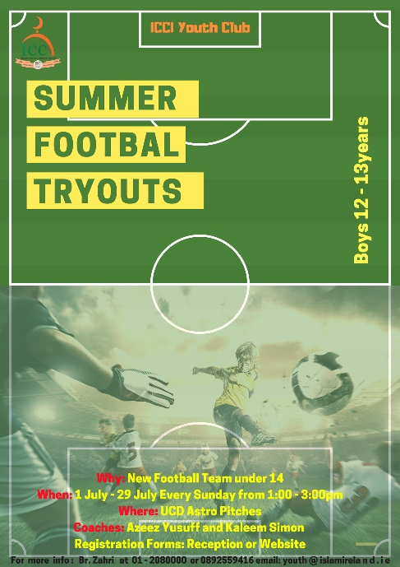
Registration form

Dear Parents / Brothers and sisters / Dear participants, Assalamu alaikum

The Youth Club of ICCI is organising Summer Football Program titled:

“Summer Football Tryouts”

Why: The ICCI Youth Department is starting new football team for boys under 14years

When: Sunday 1th July every Sunday until 29th July 2018 / From 1:00pm till 3pm

Where: UCD Astro pitches (5a side pitch No 1)

Who: Boys: 12 – 13 years

Fees: There will not be fee for the Football Trayouts

Coaches: Azeez Yusuff (former Shamrock Rovers FC player | Head Football Coach of SARI at present) and assistant Coach Kaleem Simon (former Bohemians FC player | Cabinteely FC player at present)

Registration: Registration is required to all the participants!

- To register, fill in the form and return it completed to the ICCI Youth Department or the Reception of ICCI.

All the Boys will be registered and will be briefed with the program and the rules and regulations of the Summer Football Trayouts. The boys have to come to the UCD Astro pitches (pitch No 1) with their parents. Supervisors will be helping throughout the program and will not tolerate any bad behaviour. More importantly the boys will have to bring any medicine they may require (inhalers, tablet etc.), and will need to notify us of any illness they may have. Everyone is responsible for their own belongings.

Please note that every participant should bring the following:
- Football gear (football clothing, Soft football shoes, water etc.)
- Medication if any

More info: br. Zahri at 01-208 0000 or 0892559416 email: youth@islamireland.ie or www.islamireland.ie
Name of Participant________________________________________________________________/

Date of Birth: ________/ _________/ _________/ Years: ________________________________/

Mobile number: ___________________________/ email: ________________________________/

School: _________________________________/ Class: ________________________________/

Home Address: _____________________________________________________________________/

Medical/Health Details of child
Name of Doctor: ____________________________/ Doctor’s telephone no. ___________________/

Any comments: ____________________________________________________________________/ Please list any health concerns, eg. allergies, asthma, etc.:

Parent/Guardian

I_____________________________ Parent/Guardian of________________________ am aware that playing or practicing to play any sport can be dangerous involving many RISKS OF INJURY. I understand that the dangers of playing or practicing include but are not limited to death, serious neck and spinal cord injuries, serious injury to virtually all internal organs, bones, joints, ligaments, muscles and all other elements of the skeletal/muscular system.

I recognize the dangers of practicing or playing and agree to assume the risk. I also recognize the importance of following the coaches and instruction regarding skills, safety, and team rules.

My son has my permission to play/practice in ICCI Youth Club sponsored sports. The terms hereof shall serve as a release and assumption of risk for my heirs, estate, executor, administrator, assignees, and for all members of my family.

Photography - Your child may have photographs taken during activities which may be used in promotional material and publicity in conjunction with the programmes of ICCI Youth Club including its website. These images will be produced within the guidelines set out in our Child Protection Policy. Please tick the box if you do not give your permission for taking pictures of your son.

In case of an emergency please contact me on tel.___________________________ or

____________________________________________ on tel. _____________________

I give consent for my son to participate in the Sumer Football Trayouts Program. I have read and agreed with the information and rules and regulations. I also give consent that his age is the correct age as stated above.

Signature of Parent:_____________ Date:______________ Signature of Participant _____________

Importan: Supervision and Discipline
- The Youth Club provide an Islamic alternative for the modern times the youth live in. It also provides guidance and nurturing of your son on Islamic morals and etiquettes during the Sports Programs. There are Coaches and Supervisors in each Program/Activity.
- Your son must adhere to Islamic morals, practices and norms during the entire sports program.
- The ICCI discipline procedure as outlined in the ICCI discipline policy must be agreed upon by the parents and adhered to by the participant.
- The application form should be signed by the parent/guardian and the participant.
- Parents will bear the full responsibility including any financial costs for participant who does not listen and abide to coaches and supervisors and subsequently hurts himself or causes any damage, In all these cases the ICCI Youth Club of ICCI does not accept any responsibility.

