ICCI Youth Club
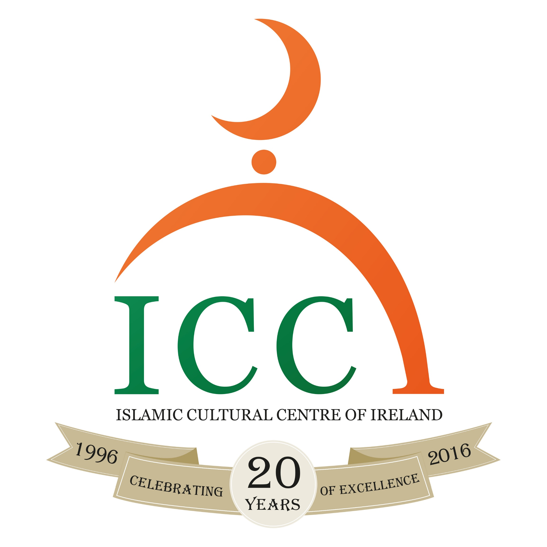

Registration form

Dear Parents, The Youth Club of ICCI is organising Summer Muslim Road Trip for boys titled:

“Ireland Bottom to Top”

When: Sunday 15th July until Wednesday 18th July 2018 (4 Days);

Where: Mizen Head the Most Southern part of Ireland and Malin Head the Most Northern part of Ireland and also Visiting many interesting places along the way. Sleeping in Killarney Mesjid in Ballyhounas Mosque and Letterkenny Mesjid.

Who: Boys: 14 – 17 years

Why and How: Utilizing the Summer School Holiday with structured recreational activities. - The program will consist of Exploring many interesting places in Ireland | the Most Southern and the Most Northern points | Sleeping in Masjids | Meeting many Muslim Communities across Ireland and more

Fees: The contribution of the cost for each participant is €70
Registration: Places based on 'first come first serve basis' - Limited places!
Deadline for registration and payment: Friday 13th July 2018.

- To register, fill in the form and return it completed together with the fee of €70 to the ICCI Youth Department or the Reception of ICCI.

- The Bus will leave from the ICCI on Sunday 15th July 2018 at 7am.
- Coming Back on Wednesday 18th July afternoon at around 7:00pm inshaallah

All the Boys will be registered and will be briefed with the program, activities and the rules and regulations of the trip. The boys will be traveling with a Bus from ICCI. Supervisors will be helping throughout the program and will not tolerate any bad behaviour. More importantly the boys will have to bring any medicine they may require (inhalers, tablet etc.), and will need to notify us of any illness they may have. Everyone is responsible for their own belongings.

Please note that every participant should bring the following:

- Own Qur’an, pen and notebook
- Sleeping bag, Toiletries
- Clothing(2 sets of Old clothing, rain jacket & trousers, Old pair of runners, Warm clothes, Swimsuit, Towels, Plastic bags)
- Medication if any
More info: br. Zahri at 01-208 0000 or 0892559416 email: youth@islamireland.ie or www.islamireland.ie
Name of Participant________________________________________________________________/

Date of Birth: ________/ _________/ _________/ Years: ________________________________/

Mobile number: ___________________________/ email: ________________________________/

Address: __________________________________________________________________________/

Any comments: ____________________________________________________________________/

Parent/Guardian

I_____________________________ Parent/Guardian of________________________ give consent for my son to participate in the Summer Trip. I have read and agreed with the information and rules and regulations below and overleaf. I also give consent that his age is the correct age as stated above.
In case of an emergency please contact me on tel.___________________________ or __________________________________________ on tel. _____________________
I have enclosed a contribution of €70

Signature of Parent:_____________ Date:______________ Signature of Participant _____________

Receipt: The ICCI Youth Department Received ___________ euro fee for the Summer Trip 2018 from _____________________________________________Signature_________________________

Importan: Supervision and Discipline
- The Youth Club provide an Islamic alternative for the modern times the youth live in. It also provides guidance, Tarbiyah and nurturing of your son on Islamic morals and etiquettes during the camp / trip. There are supervisors in each activity.
- Your son must abide by the Tarbiyah program as set out by the ICCI youth coordinator, such as offering the five daily prayers, reading a portion of the Qur’an on a daily basis, been punctual and attentive during talks and other activities
- Your son must adhere to Islamic morals, practices and norms during the entire camp/trip.
- The ICCI discipline procedure as outlined in the ICCI discipline policy must be agreed upon by the parents and adhered to by the participant. The Discipline policy offences include: 1. Leaving the group without the permission of trip in charge ( Zahri). 2. Disrespect of elders and rudeness to them. 3. Behaviour in Public which is against accepted Islamic norms or tarnishes the image of the ICCI or is against the rules and regulations of a particular place or an event or which breaks the law. 4. Stealing. 5. Vandalism and behaviour that constitutes a danger to ones self or others around him. 6. Fighting. 7. Damage to property/litter and behaviour that constitutes a danger to ones self or others around him out of negligence. 8. Vulgar behaviour, swearing, insulting, bulling and provocation to each other. 9. Continual disobedience/disrespect of the youth supervisors/leader/speakers. As well as a discipline policy, there will also be a positive appraisal points system. They include: 1. Attendance of the activities and prayers on exact time. 2. Giving Salaam at all the time and showing kindness and generosity to each other. 3. Outstanding help, assistance and sacrifice for Allah. 4. Excellent presentation, speech, talk or Performance. 5. Thorough execution of tasks as per leader, such as cleaning, serving… 6. No breaking of the program’s rules.
- The application form should be signed by the parent/guardian and the participant.
- Parents will bear the full responsibility including any financial costs for participant who does not listen to supervisors and subsequently hurts himself or causes any damage, also in a cases where the participant have had to be sent home as a result of continuous misbehavior that is detrimental to the group as a whole. In all these cases the Youth Club of ICCI does not accept any responsibility.

