ICCI Youth Club
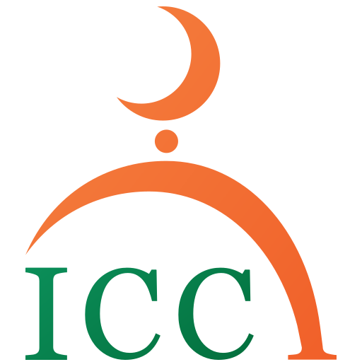

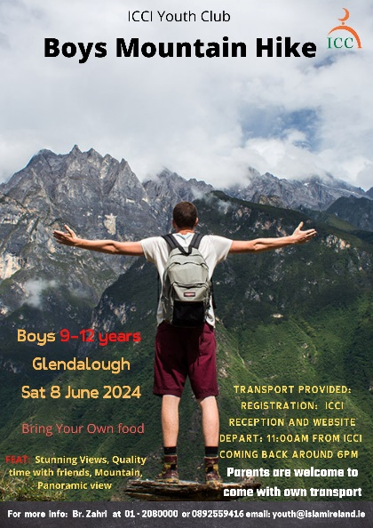
Registration form

Dear Parents/Guardians, the Youth Club of ICCI is organising Mountain Hike for boys titled:

“Discovering Allah’s Beautiful Creation”

When: Saturday 8th June 2024; Time: 11:00am – 6:00pm

Where: Glendalough Co. Wicklow

Who: Boys: 9 – 12 years

Why and How: Utilizing the School Holidays with structured recreational activities. – This is a part of a program that will consist of Exploring many interesting places in Ireland | Discovering other Muslim Communities across Ireland and more…

Fees: Free of charge for this activity;
Registration deadline: by Friday 7th June 2024 | Download the Parent Consent form or get it from ICCI Reception

- The transport: Transport provided. Bus will leave the ICCI at 11:00am
- Coming Back to ICCI: Same day at around 6:00pm Insha’Allah
- NOTE: Fathers can join too, provided they have their own transport (optional);
The meeting point is at 11:45am in Glendalough Lower car park – follow the link below, https://www.google.com/maps/place/Glendalough+Lower+Car+Park/@53.0103074,-6.3222264,17z/data=!3m1!4b1!4m6!3m5!1s0x486797ad615f71ab:0xbd376ee80a6349c6!8m2!3d53.0103074!4d-6.3222264!16s%2Fg%2F11c3sqhn58?hl=en&entry=ttu
All the Boys will be registered and will be briefed with the program, activities the rules and regulations of the trip. Supervisors will be helping throughout the program and will not tolerate any bad behaviour. More importantly the boys will have to bring any medicine they may require (inhalers, tablet etc.), and will need to notify us of any illness they may have. Everyone is responsible for their own belongings.

Please note that every participant should bring the following:

- Own food (sandwiches, water, snacks etc.)
- Clothing and Gear ((Mountain small backpack, rain jacket & trousers, hiking boots – (runners will not be suitable), small towel etc.))
- Medication if any

More info: br. Zahri at 01-208 0000 or 0892559416 email: youth@islamireland.ie or www.islamireland.ie
Name of Participant________________________________________________________________/

Date of Birth: ________/ _________/ _________/ Years: ________________________________/

Mobile number: ___________________________/ email: ________________________________/

Address: __________________________________________________________________________/

Any comments: ____________________________________________________________________/

Parent/Guardian

I_____________________________ Parent/Guardian of________________________ give consent for my son to participate in the Mountain Hike. I have read and agreed with the information and rules and regulations below and overleaf. I also give consent that his age is the correct age as stated above.
In case of an emergency please contact me on tel.___________________________ or __________________________________________ on tel. _____________________
I

Signature of Parent:_____________ Date:______________ Signature of Participant _____________

Receipt: The ICCI Youth Department Received ___Free___ euro fee for the Mountain Hike 2024 from _____________________________________________Signature_________________________

Importan: Supervision and Discipline
- The Youth Club provide an Islamic alternative for the modern times the youth live in. It also provides guidance, Tarbiyah and nurturing of your son on Islamic morals and etiquettes during the camp / trip. There are supervisors in each activity;
- Your son must abide by the Tarbiyah program as set out by the ICCI Youth Department, such as offering the five daily prayers, reading a portion of the Qur’an on a daily basis, been punctual and attentive during talks and other activities;
- Your son must adhere to Islamic morals, practices and norms during the entire camp/trip;
- The ICCI discipline procedure as outlined in the ICCI discipline policy must be agreed upon by the parents and adhered to by the participant: The Discipline policy offences include: 1. Leaving the group without the permission of trip in charge (br. Zahri). 2. Disrespect of elders and rudeness to them. 3. Behaviour in Public which is against accepted Islamic norms or tarnishes the image of the ICCI or is against the rules and regulations of a particular place or an event or which breaks the law. 4. Stealing. 5. Vandalism and behaviour that constitutes a danger to ones self or others around him. 6. Fighting. 7. Damage to property/litter and behaviour that constitutes a danger to ones self or others around him out of negligence. 8. Vulgar behaviour, swearing, insulting, bulling and provocation to each other. 9. Continual disobedience/disrespect of the youth supervisors/leader/speakers. As well as a discipline policy, there will also be a positive appraisal points system. They include: 1. Attendance of the activities and prayers on exact time. 2. Giving Salaam at all the time and showing kindness and generosity to each other. 3. Outstanding help, assistance and sacrifice for Allah. 4. Excellent presentation, speech, talk or Performance. 5. Thorough execution of tasks as per leader, such as cleaning, serving… 6. No breaking of the program’s rules;
- The application form should be signed by the parent/guardian and the participant;
- Parents will bear the full responsibility including any financial costs for participant who does not follows the supervisors and subsequently hurts himself or causes any damage, also in a cases where the participant have had to be sent home as a result of continuous misbehavior that is detrimental to the group as a whole. In all these cases the Youth Club of ICCI does not accept any responsibility.

